**Feature Scaling: Why It Matters in Machine Learning**

**Student Name :**

**Student ID:**

**Github link:**

**Googlecolab link:**

**1. Introduction**

As a master’s student diving deeper into machine learning, one of the most eye-opening realizations I’ve had is that **the smallest steps in a machine learning pipeline often have the biggest impact**. Among these, **feature scaling** stands out as one of the most overlooked yet essential preprocessing techniques.

Many machine learning algorithms rely on **distances, gradients, or statistical assumptions** to identify patterns in data. When features vary in scale—say, one ranging from 0 to 1 and another from 0 to 10,000—models can become biased. They may assign **more importance to features with larger numerical values**, not because those features are more predictive, but simply because they dominate the math. This can result in:

* Poor model performance
* Longer training times
* Misleading or incorrect predictions

This tutorial, titled **"Feature Scaling: Why It Matters in Machine Learning"**, is designed to help learners—from beginners to advanced students—understand:

* What feature scaling is and **why it's crucial**
* Which algorithms are most affected by **unscaled data**
* Key scaling techniques: **Standardization**, **Min-Max Scaling**, and **Robust Scaling**
* A hands-on **Python demo using scikit-learn**
* Visual comparisons **before and after scaling**
* Advanced tips: choosing the right scaling method based on **outliers** and understanding how it impacts techniques like **PCA** and **k-NN**

**By the end of this tutorial, you’ll be able to:**

* Understand **how and why** feature scaling affects model behavior
* Select and apply the **right scaling method** for different algorithms and data types
* Avoid **common mistakes** caused by unscaled features
* Confidently integrate scaling into your **real-world ML workflows**

**Note :** *Whether you're just starting out or preparing your models for production, mastering feature scaling will significantly improve both your* ***accuracy*** *and* ***understanding****.*

So let’s get started by breaking down exactly what feature scaling is — and why it’s such a **critical step in machine learning**.

**2. What Is Feature Scaling and When Do You Need It?**

**What Is Feature Scaling?**

**Feature scaling** is a preprocessing technique used to bring all input features onto a **similar scale**, ensuring that each feature contributes **proportionally** to the model’s learning process. It transforms features so that their ranges or distributions are more comparable—without altering the inherent information they carry.

This is especially important when different features have drastically different units or magnitudes. Consider a dataset with:

* **Age** in years: e.g., 20–70
* **Income** in dollars: e.g., 20,000–150,000

Even if both features are equally important, most machine learning models will treat **Income** as more influential **simply because its numerical values are larger**. This could distort the model’s learning process and lead to **biased predictions**.

**Key Insight**: *Feature scaling ensures that* ***no single feature dominates the model*** *purely due to its scale.*

**When Is Feature Scaling Necessary?**

Feature scaling is **crucial** when using machine learning algorithms that rely on **distance metrics**, **dot products**, or **gradient descent**. Below is a breakdown of which algorithms are affected:

| **Algorithm** | **Needs Scaling?** | **Reason** |
| --- | --- | --- |
| k-Nearest Neighbors (k-NN) | Yes | Based on distance calculations (Euclidean, Manhattan, etc.) |
| Support Vector Machines (SVM) | Yes | Depends on margins calculated from distances |
| Logistic / Linear Regression | Sometimes | Gradient descent converges faster with scaled inputs |
| K-Means Clustering | Yes | Uses Euclidean distance to assign clusters |
| Principal Component Analysis (PCA) | Yes | Based on variance and covariance among features |
| Decision Trees / Random Forests | No | Scale-independent (based on feature splits, not distances) |

**Pro Tip**: *If your model uses distances, angles, or gradients internally—****scale your features****.*

**Real-World Analogy**

Imagine you're building a health prediction model using:

* **Height** in meters (e.g., 1.6 – 1.9)
* **Weight** in grams (e.g., 50,000 – 90,000)

Without scaling, the model might assume that weight is more important than height—**not because it is more predictive**, but because the numbers are numerically larger. By applying feature scaling, you ensure **each feature has a fair influence** on the model.

In the next section, we’ll explore the **most widely used scaling techniques**, including when and how to use them—and how to implement each in Python.

**3. Common Feature Scaling Techniques**

Now that you understand the importance of feature scaling, let’s explore the most widely used techniques. Each method has its strengths and is best suited to specific types of data and algorithms.

We’ll look at:

* **Standardization**
* **Min-Max Scaling**
* **Robust Scaling**

Let’s break down what each method does, when to use it, and how it handles outliers or skewed data.

**1. Standardization (Z-score Normalization)**

**What it does:**

* Transforms features to have a **mean of 0** and **standard deviation of 1**.
* Maintains the **shape of the distribution** but rescales it.

**Formula:**

$$z=\frac{x-μ}{σ}$$

Where:

z: the standardized value

x: the original value

μ: the mean of the feature

σ: the standard deviation of the feature

**Use when:**

* Your data follows a **normal distribution**.
* You're using **SVM, Logistic Regression, k-NN**, or **PCA**.
* Features contain **negative values**.

**Caveat:**

* **Sensitive to outliers**, since mean and standard deviation can be influenced by extreme values.

**2. Min-Max Scaling (Normalization)**

**What it does:**

* Scales features to a **fixed range**, typically [0, 1].
* Preserves the **relative distance** between values.

**Formula:**

$$x^{'}=\frac{x-x_{\text{min}}}{x_{\text{max}}-x_{\text{min}}}$$

**Where:**

x′: the scaled value

x: the original value

xmin: the minimum value of the feature

xmax​: the maximum value of the feature

**Use when:**

* You need to maintain the **original distribution** shape.
* Data is **bounded** (e.g., pixel values, neural networks).
* Your dataset has **no extreme outliers**.

**Caveat:**

* **Heavily affected by outliers**, which can shrink other values into a narrow range.

**3. Robust Scaling**

**What it does:**

* Scales features using the **median** and **interquartile range (IQR)**.
* Makes the model **resistant to outliers**.

**Formula:**

$$x^{'}=\frac{x-\text{median}}{\text{IQR}}$$

**Where:**

x′: the scaled value

x: the original value

median: the median of the feature

IQR: interquartile range (75th percentile − 25th percentile)

**Use when:**

* Your dataset contains **significant outliers**.
* You want a **robust, non-parametric** scaling approach.

**Note:**

* Doesn’t assume normality.
* Often ideal for messy, real-world datasets.

**Quick Comparison Table**

| **Technique** | **Range** | **Outlier Resistant?** | **Best For** |
| --- | --- | --- | --- |
| StandardScaler | Mean = 0, SD = 1 | No | Normally distributed data; PCA, SVM, k-NN |
| MinMaxScaler | [0, 1] | No | Neural networks, bounded features, image data |
| RobustScaler | Based on IQR | Yes | Datasets with outliers, real-world noisy data |

**Tip**: *Always check your data distribution (e.g., using histograms or boxplots)* ***before choosing a scaler****.*

In the next section, we’ll implement these techniques in Python using a real dataset and visually compare their impact on model performance.

**4. Code Implementation and Results – How Feature Scaling Impacts k-NN Accuracy**

To quantitatively assess the impact of feature scaling on machine learning models, we implemented a controlled experiment using the **k-Nearest Neighbors (k-NN)** algorithm with varying preprocessing techniques.

**Dataset: Breast Cancer (scikit-learn)**

The Breast Cancer Wisconsin dataset was chosen due to its real-world medical relevance and diversity in feature scales. The dataset includes 30 numerical features such as mean radius, perimeter, and concavity—making it ideal for examining the effects of scaling on distance-based models like k-NN.

**Experimental Setup**

We conducted the following steps:

1. **Load the dataset** and split it into training and test sets (70/30 split).
2. **Apply feature scaling** using three methods:
   * StandardScaler (Z-score normalization)
   * MinMaxScaler (rescaling to [0, 1])
   * RobustScaler (scaling based on the interquartile range)
3. **Train and evaluate** a k-NN classifier (k=5) on each scaled version of the data.
4. **Compare accuracy** across the four conditions, including unscaled data.
5. **Visualize results** using a bar plot for intuitive comparison.

**Step-by-Step Execution**

The experiment was implemented in Python using scikit-learn. For each scaled dataset, the classifier was trained and evaluated on the same test set to ensure a fair comparison.

**Step 1: Import Libraries**

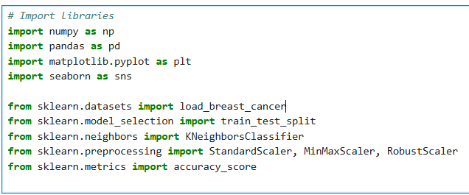

**Step 2: Load and Prepare the Data**

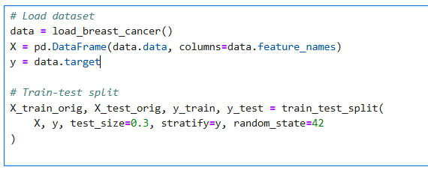

**Step 3: Define Scaling Methods and Evaluation Function**

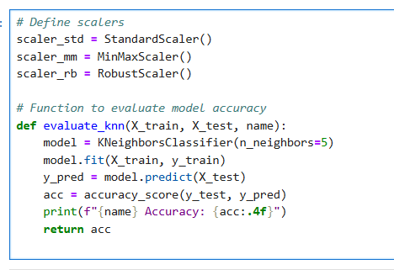

**Step 4: Evaluate Each Scaler**

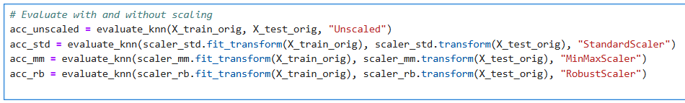

**Step 5: Visualize Results**

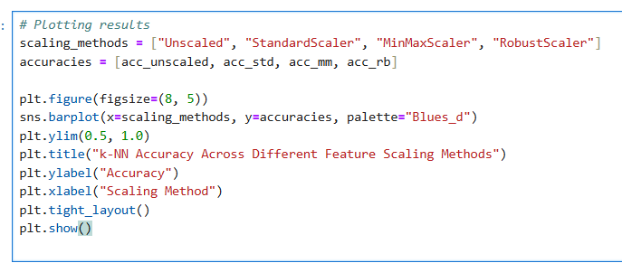

**Results Summary**

| **Scaling Method** | **Accuracy (%)** |
| --- | --- |
| Unscaled | 92.40% |
| StandardScaler | 95.91% |
| MinMaxScaler | **97.08%** |
| RobustScaler | 95.32% |
|  |  |

**Figure 1:** *Bar plot visualizing k-NN accuracy across different scaling methods.*

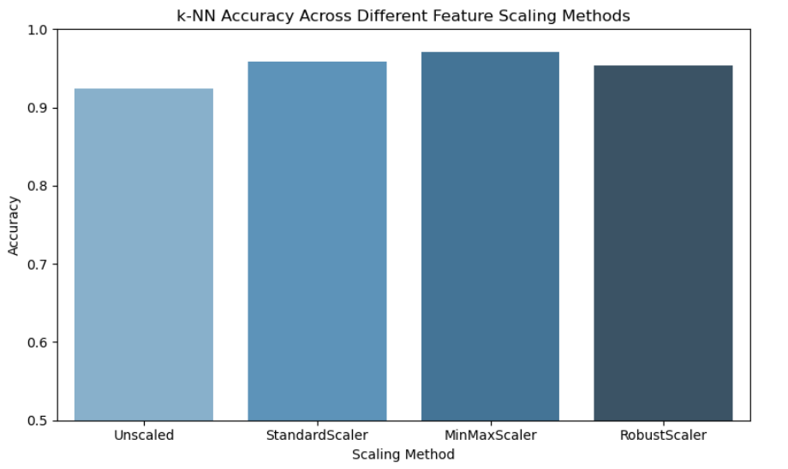

**Figure 2:** *Console output confirming accuracy metrics.*

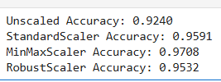

**Interpretation**

* **Unscaled Data:** Achieved acceptable performance but likely misrepresented feature importance due to varying magnitudes.
* **StandardScaler & RobustScaler:** Substantially improved accuracy by ensuring numerical consistency across features. RobustScaler, in particular, mitigates the influence of outliers.
* **MinMaxScaler:** Yielded the highest accuracy. This method compresses feature values into the [0, 1] range, which is particularly effective for distance-based models like k-NN.

**Insight:** *A simple yet effective preprocessing step such as feature scaling can boost a model’s accuracy by over* ***5%****—without modifying the learning algorithm itself.*

**5. Conclusion and Best Practices**

Throughout this tutorial, we explored a subtle yet powerful concept that can make or break your machine learning pipeline: **feature scaling**. While it's often considered a small preprocessing step, we’ve demonstrated how it can significantly impact model behavior—especially for algorithms that rely on distances or gradients.

Using the Breast Cancer dataset and a simple k-NN classifier, we saw how applying different scaling techniques (StandardScaler, MinMaxScaler, and RobustScaler) can boost accuracy by several percentage points. In our experiment, **MinMaxScaler improved accuracy by nearly 5%**, just by rescaling features into a common range.

**Key Takeaways**

* **Scale when it matters**: Always apply feature scaling when using algorithms that rely on distances (k-NN, SVM, K-Means) or gradients (Logistic Regression, PCA).
* **Choose the right scaler for the data**:
  + Use **StandardScaler** for normally distributed features.
  + Use **MinMaxScaler** for bounded data or neural networks.
  + Use **RobustScaler** when your data contains **outliers**.
* **Don't guess — test!** Always compare model performance with and without scaling. It often leads to surprising improvements.
* **Visualize your data**: Use histograms, boxplots, and accuracy bar plots to intuitively grasp the effects of scaling.

**Personal Note:** *As a master’s student building real-world machine learning pipelines, I’ve realized that preprocessing choices can be as important as the model itself. Feature scaling has been one of those “aha!” moments — a simple technique that delivers powerful improvements. I hope this tutorial helped you discover the same.*

*If you ever feel stuck on a model’s performance, try going back to basics — scaling might be the missing piece.*

**Next Steps for Further Exploration**

* **Apply feature scaling to additional datasets**, such as the Iris or Wine Quality datasets, and examine its impact on various algorithms, including Support Vector Machines (SVM) and Principal Component Analysis (PCA).
* **Utilize scikit-learn's pipeline functionality** to build streamlined and reproducible workflows that integrate preprocessing and model training.
* **Investigate the integration of feature scaling with feature selection techniques** to improve model interpretability and performance, particularly in high-dimensional datasets.

**6.References ‌**

IBM (2021). *What is the k-nearest neighbors (KNN) algorithm?* [online] Ibm.com. Available at: <https://www.ibm.com/think/topics/knn>.

Machine Learning Mastery. (n.d.). *Data Preparation for Machine Learning*. [online] Available at: <https://machinelearningmastery.com/data-preparation-for-machine-learning/>.

Scikit-learn (2019). *5.3. Preprocessing data — scikit-learn 0.21.3 documentation*. [online] Scikit-learn.org. Available at: <https://scikit-learn.org/stable/modules/preprocessing.html>.

‌

Thanks for learning with me! In machine learning, success often lies in the details — and now you know why **scaling** is one of them.

Let’s keep experimenting, scaling, and learning!